NOTES ABOUT THE DATASET

UNHCR population types
- REF — Refugees
People who have been formally recognized as refugees (by a government or UNHCR), typically under the 1951 Refugee Convention.

- ROC — Refugee-like situations
People who are in a similar situation to refugees, but haven’t been formally granted refugee status (often due to administrative or political reasons).
- ASY — Asylum-seekers
People who have applied for asylum but whose claim has not yet been decided.
- OIP — Other people in need of international protection
A broader category: people who don’t fit neatly into the standard legal groups but still require protection or assistance from UNHCR.
In 1962 -- 143 world countries (from Wikipedia: https://en.wikipedia.org/wiki/List_of_modern_sovereign_states_by_date_of_formation ). 1962 Independence: Landmark independence events in 1962 included Algeria (July), Jamaica (August), Trinidad and Tobago (August), and Uganda (October).
“Since 1962, over 100 new countries have gained independence, driven by decolonization in the 1960s-70s and the breakup of the Soviet Union and Yugoslavia in the 1990s. The newest nation is South Sudan (2011). Other major recent additions include Montenegro (2006), Timor-Leste (2002), Palau (1994), Eritrea (1993), and the Czech Republic/Slovakia (1993).”
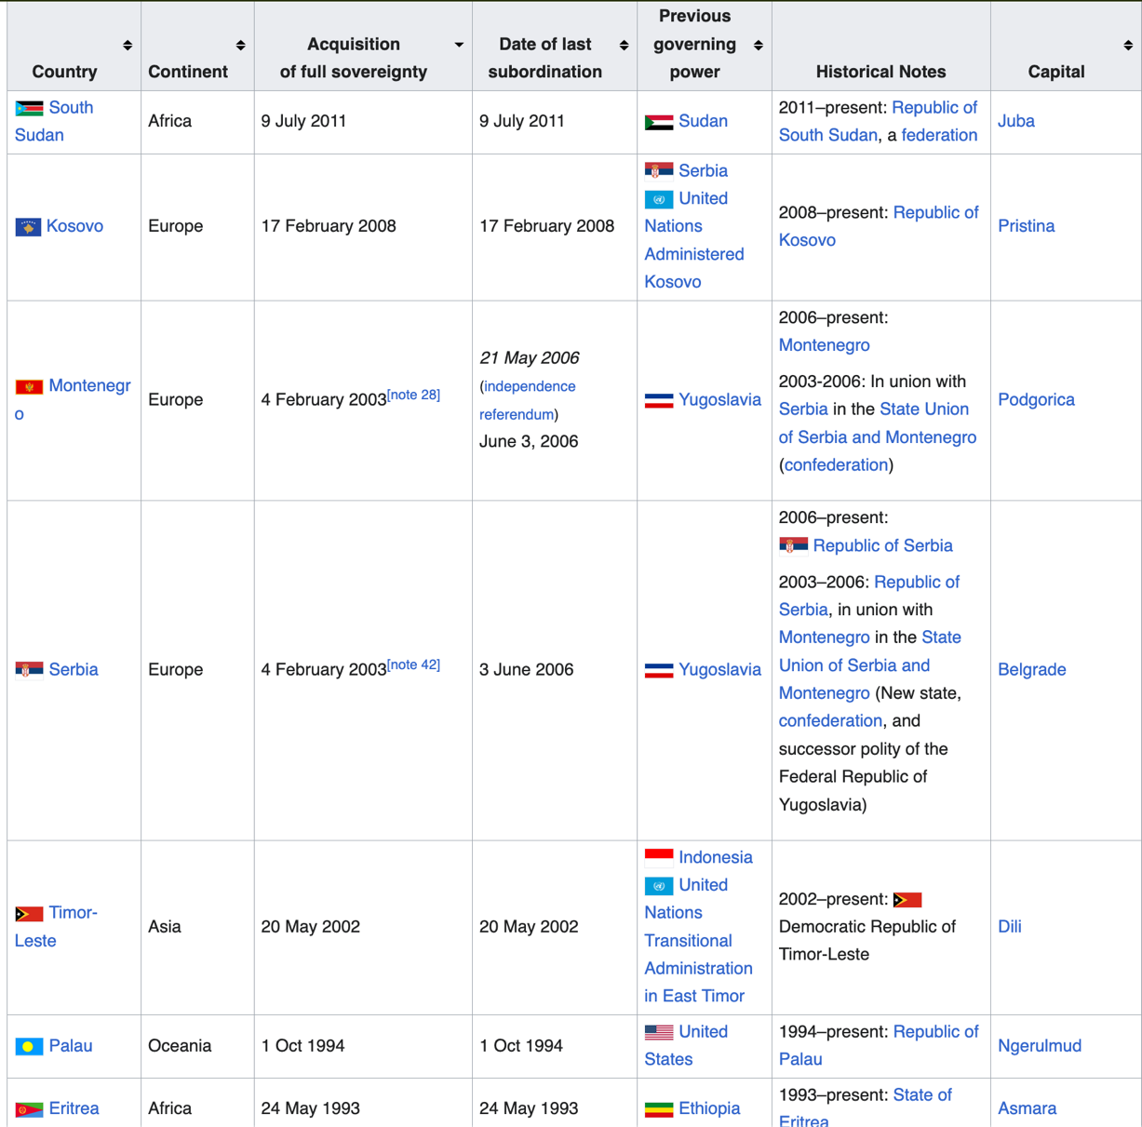

---------------------------------------------------------------------------------------------------------------------------------
OUR STORY ?
- What makes people leave? (obvious VS less obvious reasons…war and famine VS things like Brexit)
- Change pf immigration policies over time? Pick one or a few countries and see how many immigrants they accept between 1962 to today … see how those changes?
- Something about the rise in number of new countries over time ?
- Proportion of migration compared to population (Germany receiving over a million Syrians, with a population 80million total population VS Sweden receiving 300 000, total population 9 million)
---------------------------------------------------------------------------------------------------------------------------------
SHOWING THAT VISUALLY ?
Map out global movements-- heatmap/per country ?

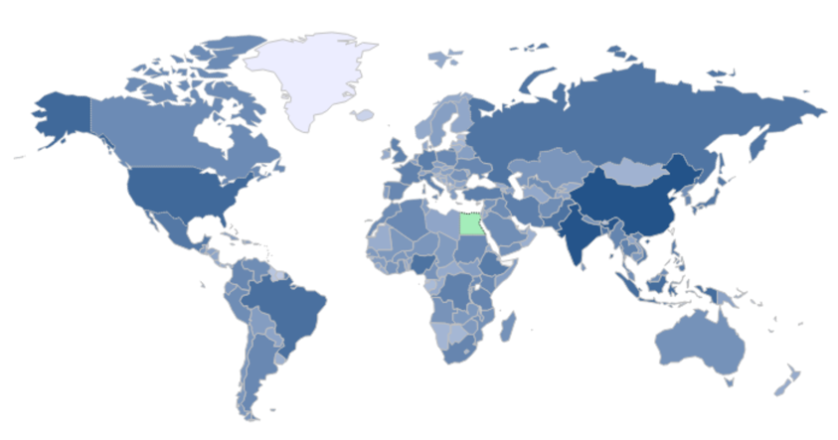
Who moved where when?
Do it for a specific year ex 1989, or 1991 (or any other) and check online if historical events match whet we see on our map too. Fall of USSR for ex. Or breaking of “yougoslavia” …
BONUS: have it map all years? See how it evolves over time?

Let’s make a Flow map?

- Flow map → because it shows movement or connections between places
- Network visualization on a map → nodes (locations) + edges (connections)
- Often also described as a spatial network graph

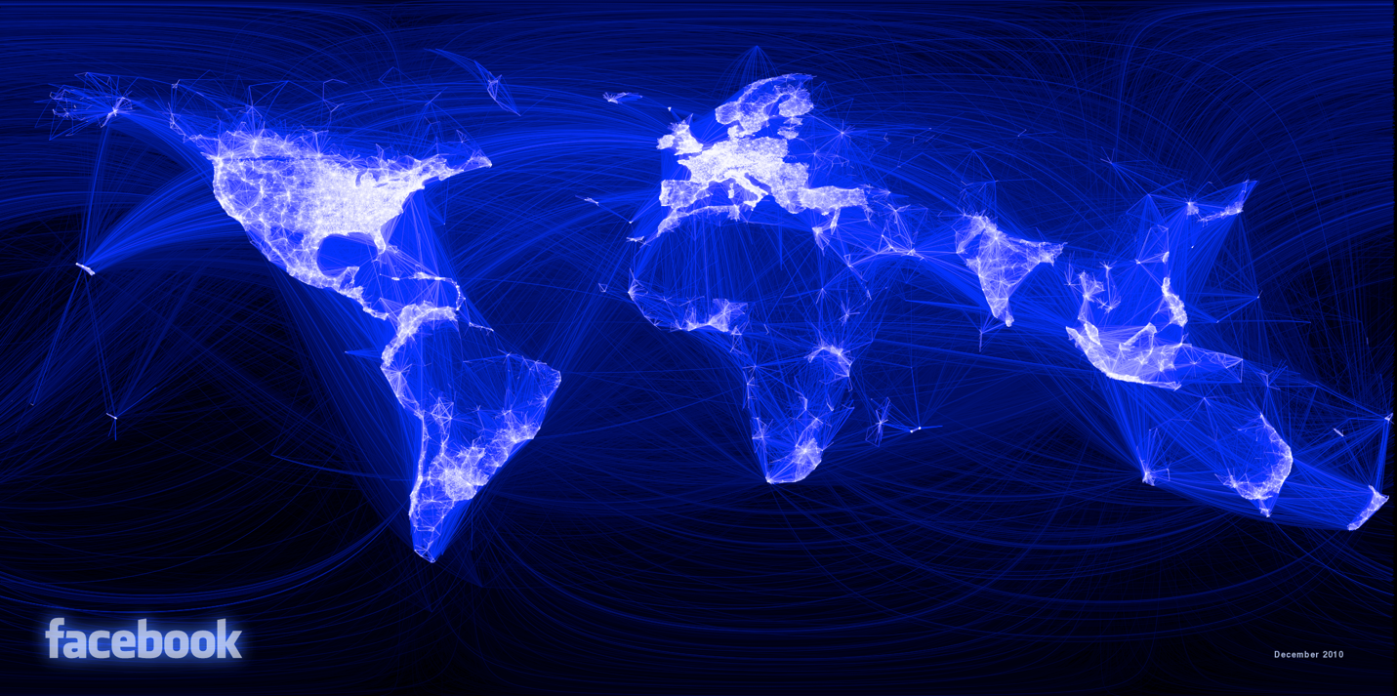

BONUS: Flow mat over time ?!?!?

If we already have two maps we could use something else?

Project Assignment A
The first part of the final project is an 1 minute movie, which should explain the central idea/concept that you will investigate in your final project. You're making the movie so that the TAs and I can give you feedback, and so that other groups can steal your ideas (and you can steal ideas from them). The movie must contain the following
- An explanation of the central idea behind your final project, e.g. think about questions such as
  - What is the idea?
Studying migration world side over time?
visualize the refugee situation from 1960’s to nowadays. Find the most displaced people, find countries that have taken inmost refugees? Reasons people leave? Top situations that force people to leave: war? Famine? Civil war?
Attractivity of countries over time? Spain and USA in the 60’s? “top destination for each year”? per capita/proportion of population
Cool to see the creation of countries over time
  - Which datasets do you need to explore the idea?,
The UN refugee dataset (handy we got it)
supplemental reading on historical facts, research on “type of people” refugee VS asylum seeker?
  - Why is it interesting?
it’s an important question about humanity!
current hot political (excuse) / topic
- A mock up of the visualization that you wish to build. (Anything is fine here. Pen and paper, MS Paint, Inkscape, D3, LLMs, anything is OK).
  - Facebook “Flow map” who goes where when in what amount?
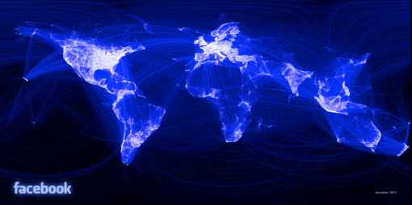
  - Heatmap Ratio map (how many people leave VS how many people arrive)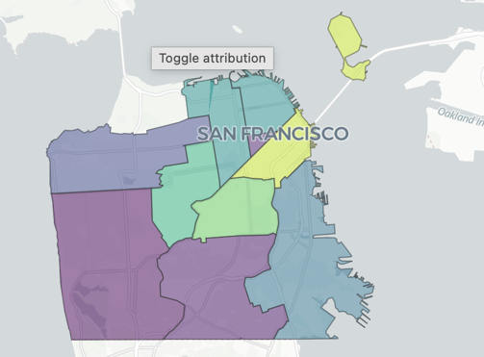
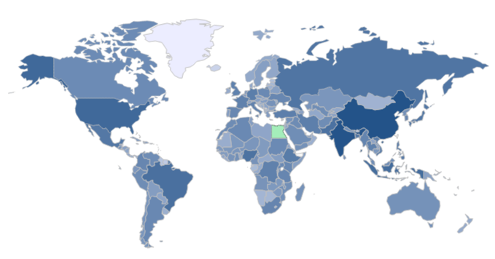
  - Plot or barchart? reason for leaving? Types of conflicts? Wars? flood? economic crisis? Famine? Top 5 biggest population movement of the year + main reason why they are leaving.

  - “attractiveness” ration of refugees VS local population


  - Scatter plot /The bubble plot x axis number of refugees that come/leave
y axis ration of migrants per population 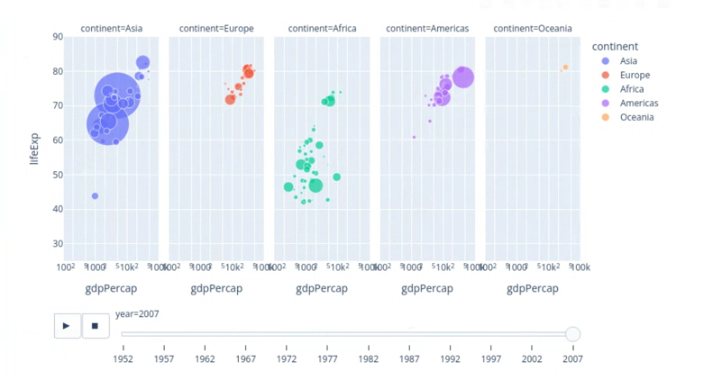

- Make sure you answer the questions
  - What genre is it? (for Genres, see section 4.3 of the Segel and Heer paper)
magazine style (scroll down explanation)
  - Why is that genre right for telling the story you want to communicate with the data
we have a complex story, we this offers a step by step guidance for our reader
- A walk-through of your preliminary data-analysis, addressing
  - What is the total size of your data? (MB, number of rows, number of variables, etc)
7.3MB biiig +100,000 datapoints
  - What are other properties? (What is the date range? Is is it geo-data?, then a quick plot of locations, etc.)
date range 1962 – 2025
not geo data but lots of country data still plottable…
  - Show the fundamental distributions of the data (similar to the work we did on SF crime data)
bar chart? Not a lot of data from 1962… more countries mentioned in 2025 (both from creation of new countries and tendency to store data)
scatter plot?
But other than that, there are no constraints. And we do appreciate funny/inventive/beautiful movies, although the academic content is most important. Note that we'll display the movie to the entire class.
(The maximum length is 1 minutes, but its OK if the movie is shorter.)
Handing in the assignment: Simply upload your video directly to DTU Learn. Or upload to a video sharing service such as YouTube or similar - and submit the link via DTU Learn.

MOVIE:
- Draw: World map drawing for intro
- Mock ups of 3 graphs we wanna show
- Magazine style for our complex story scrolling website
- Info on dataset
- Fundamental distributions? Number of total refugees per year

